**St. Francis Institute of Technology**

**Class: SE-ITA/ITB Semester: IV; A.Y. 2023-2024**

**Subject: Microprocessor Lab**

**Experiment – 7:** Compute factorial of a positive number

**1. Aim**:

Write an ALP to compute factorial of a positive number.

**2. Requirements**

DOSBox (an x86 emulator with DOS), Turbo Assembler, Turbo Debugger

**3. Pre-Experiment Exercise**

**Algorithm:**

a. Initialize the data segment.

b. Display message “enter the number to calculate factorial:$” and use INT 21h commands to take a single digit input from the user.

c. Call a procedure to calculate the factorial of the number.

d. Store the result in data memory.

**4. Laboratory Exercise:**

**Procedure:**

a. Open DOSbox and go to TASM.

b. Open a new document using the command - edit <filename>.asm

c. Write the Program and save the changes to the same file.

d. Assemble the program using the command - tasm <filename.asm>

e. If any errors are displayed, then change the code in <filename>

f. If no errors are displayed, execute the command - tlink <filename>.obj to create the executable file.

g. Next execute the command - td <filename>

h. Try to RUN the program step by step and view the changes in the registers, flags, memory, etc.

**5. Post Experiment Exercise:**

**a. Results/Calculations/Observations:**

Attach appropriate screenshots of the input from the user and output stored in memory along with the ALP.

**b. Questions:**

i. Write an ALP in TASM to calculate LCM of two 16-bit numbers. Attach appropriate screenshots.

ii. Write and ALP in TASM to calculate GCD of two 16-bit numbers. Attach appropriate screenshots.

**c. Conclusion:**

Write the conclusion/comments based on the experiment performed and the output obtained.

**d. References:**

Mention two book references and two web references.

Code:  ***RIYA INDAP,44***

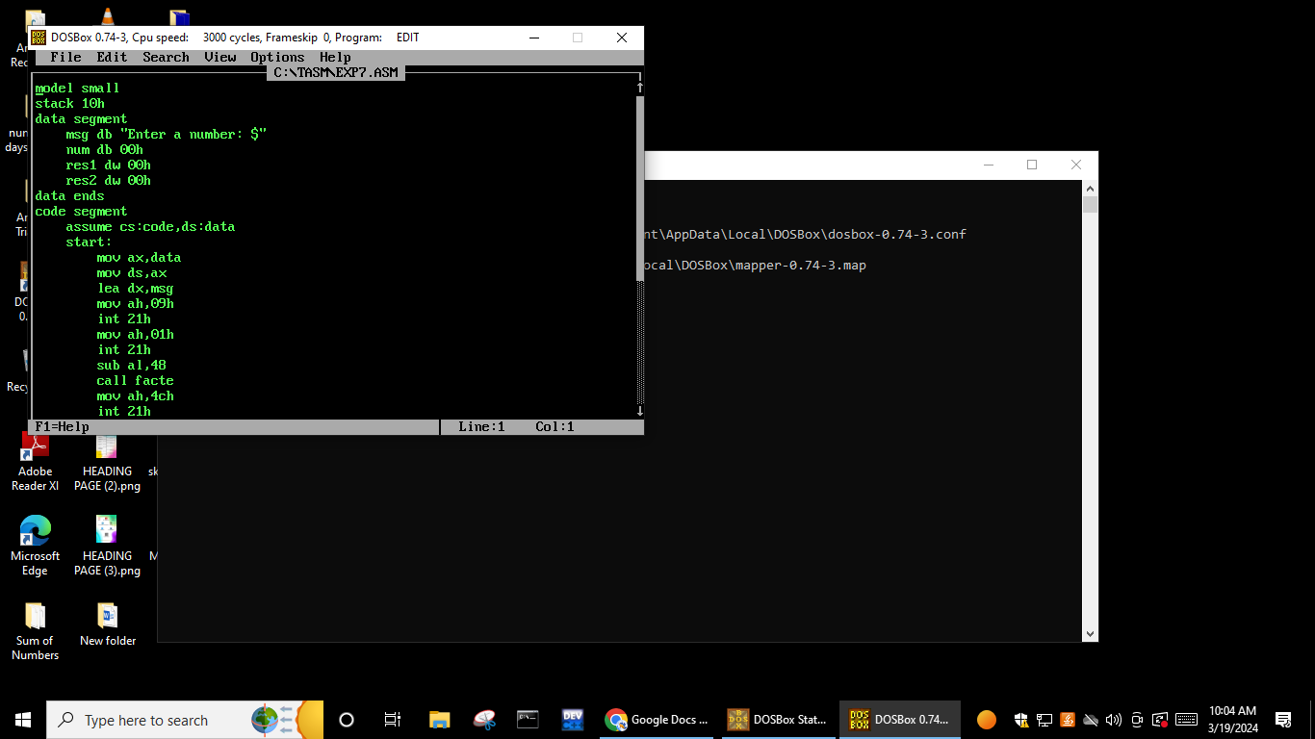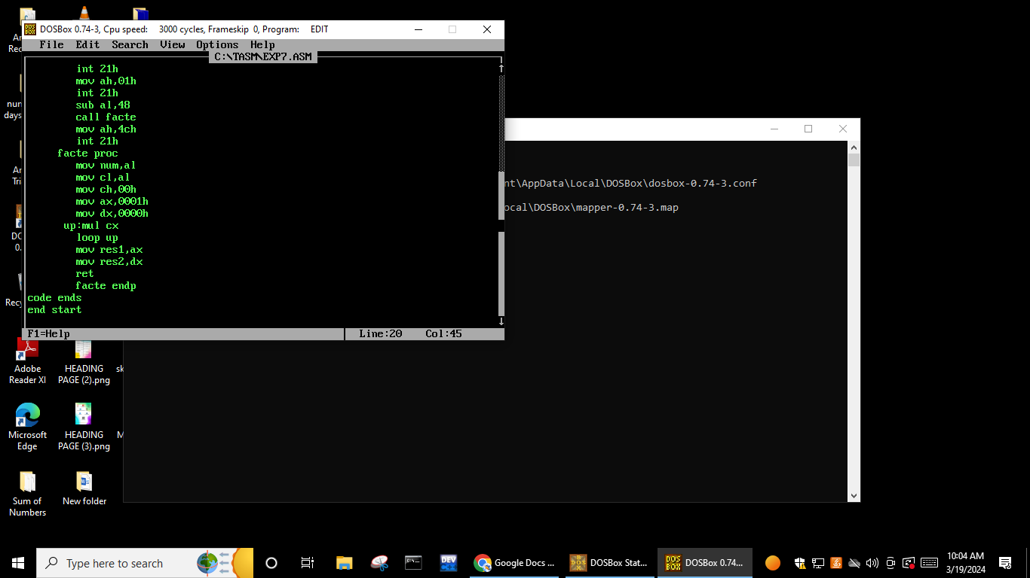

Output:

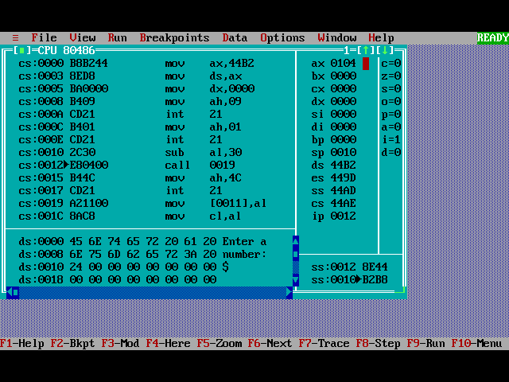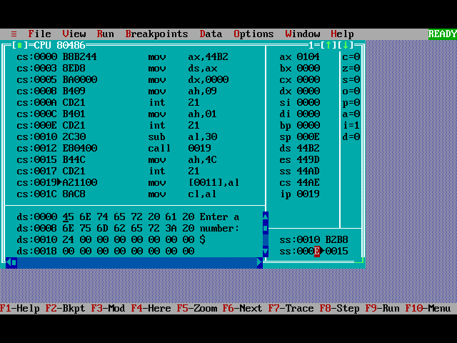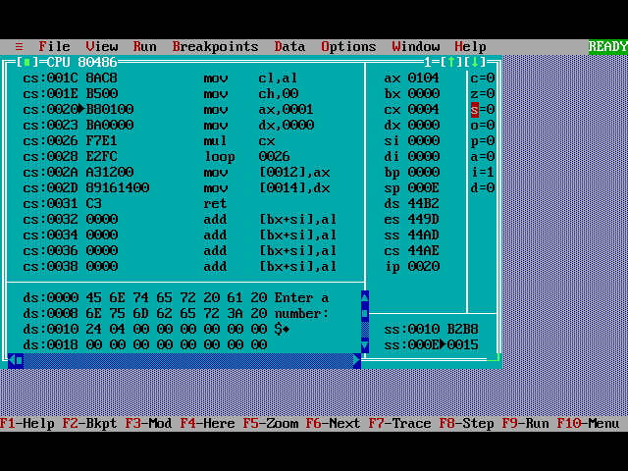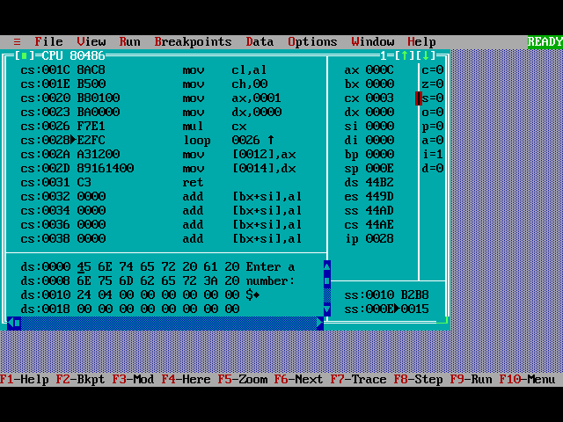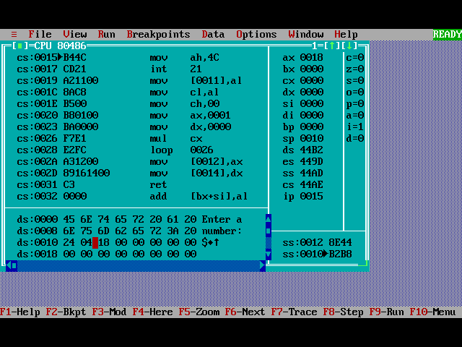

Q)Write an ALP in TASM to calculate LCM of two 16-bit numbers.

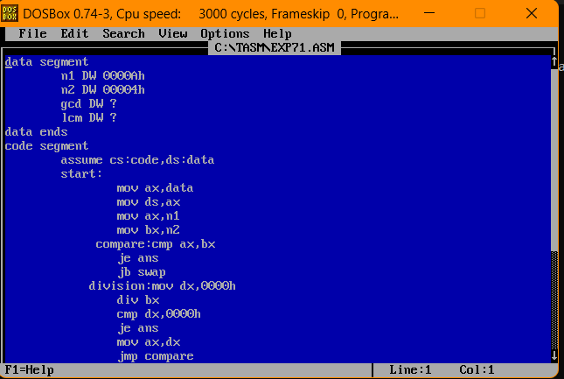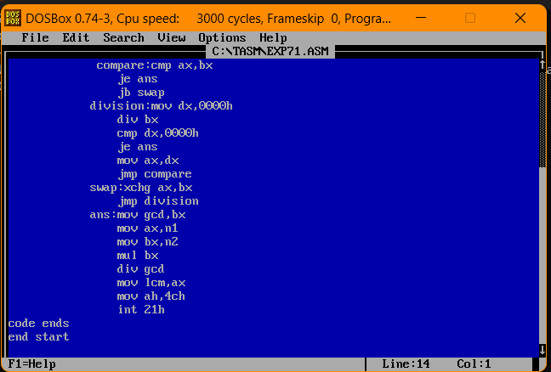

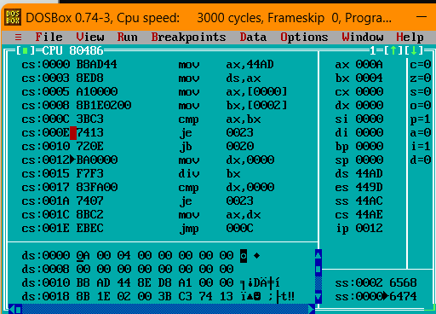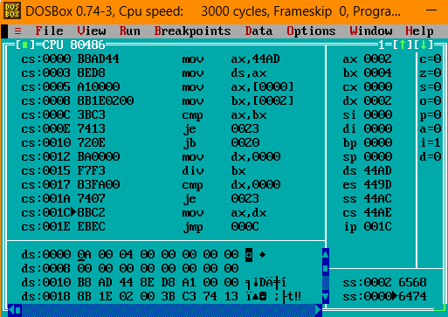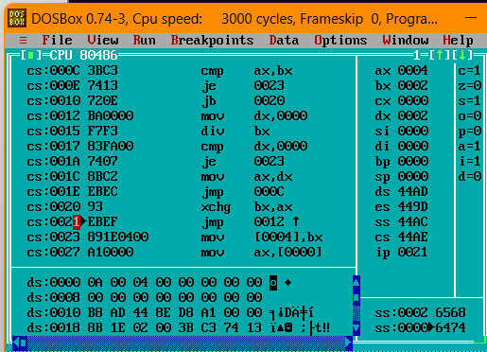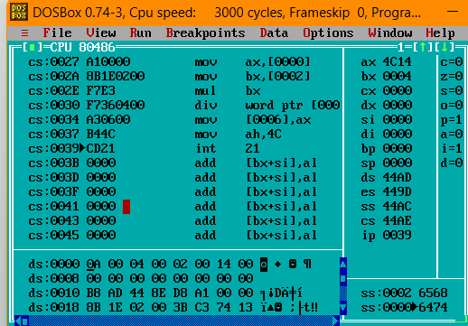

Q)Write and ALP in TASM to calculate GCD of two 16-bit numbers

